50p

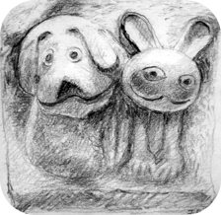

SOCIETIES FAIR 2018

Sunday, 18th November 2018

Ewyas Harold Memorial Hall

GOLDEN VALLEY GROUPS INITIATIVE

CONTENTS

 | Page
WELCOME | 1
AN INTRODUCTION TO GVGI | 2
Article: ‘HALE THE HALLS!’  with a feature on Ewyas Harold Memorial Hall | 5
IDEAS | 10
Article: ‘COMMUNITY TRANSPORT’  featuring Dore Community Transport | 11
Article: ‘THE THREE AGES | 16
PARTICIPANTS & LAYOUT OF THE STALLS | Centrefold
Article: ‘SUPPORT FOR THE SUPPORTERS’  with features on Community Catalysts, HVOSS,  Community First & Herefordshire Council | 20
SURVEYS | 27
DIRECTORY | 28
SPONSORS + NEXT TIME | inside back

WELCOME

WELCOME TO OUR FIRST SOCIETIES FAIR. Indeed, it is the very first Event of the Golden Valley Groups Initiative (GVGI). As I have no earlier events to report on or catalogue of photos to show, there is little option but to look forwards. Fortunately, the future for GVGI looks interesting. I am using this brochure to report on much of what we are planning to do over the next few years.

Next year, apart from the on-going development of our web site, we expect to host (or at least help others to host) a few Discussion Groups. Some of these will be aimed at helping various Community Groups obtain the assistance they need. Others will see if some groups can work together better than they do at the moment. Whilst Societies Fairs such as this one will probably be held every 2 years, Discussion Groups will be more frequent. How frequent they will be will depend not least on the feedback we get over the next few months, starting with any responses we receive to our Surveys (page 27). Please do consider our Surveys and let me know what you think of what we are thinking of doing!

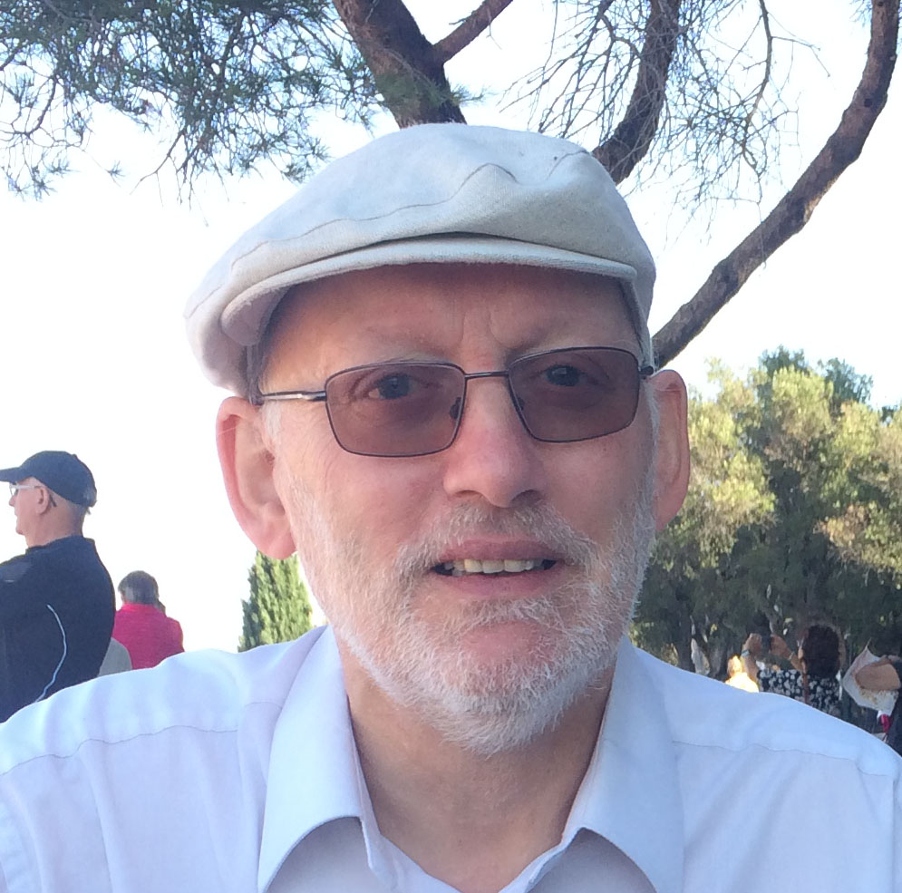
I am pleased to take this opportunity to thank everyone who helped me with the organisation of this Fair. Particular thanks are due to my wife Jackie, Ann and Carey & others at Ewyas Harold Memorial Hall, Victoria of Community Catalysts, Helen of U3A & WEA, and those who contributed to the articles in this brochure. It will all be much better organised next time!

Peter Barns-Graham
Peter@GoldenValleyGroups.uk

AN INTRODUCTION TO GVGI

GVGI was set up:
- to help publicise the many ‘Community Groups’ that are active in and around South-West Herefordshire; and
- to encourage those groups to appreciate and support each other when appropriate, paying particular attention to those that are active in and around the Golden Valley.

Our first attempts to help publicise the groups are our web site (mentioned below) and this Societies Fair. | We use the term “community groups” to cover those who support social, charitable, hobby-supporting, educational, religious, sporting and similarly community-focused activities, large or small.
Encouraging groups to appreciate & support each other is a theme you will hear us come back to time after time!
Key elements of our approach are that we are keen to keep it simple & sustainable, that we don’t get involved unless we are invited to get involved, and that we avoid reinventing wheels.
Don’t expect us to do anything complicated!

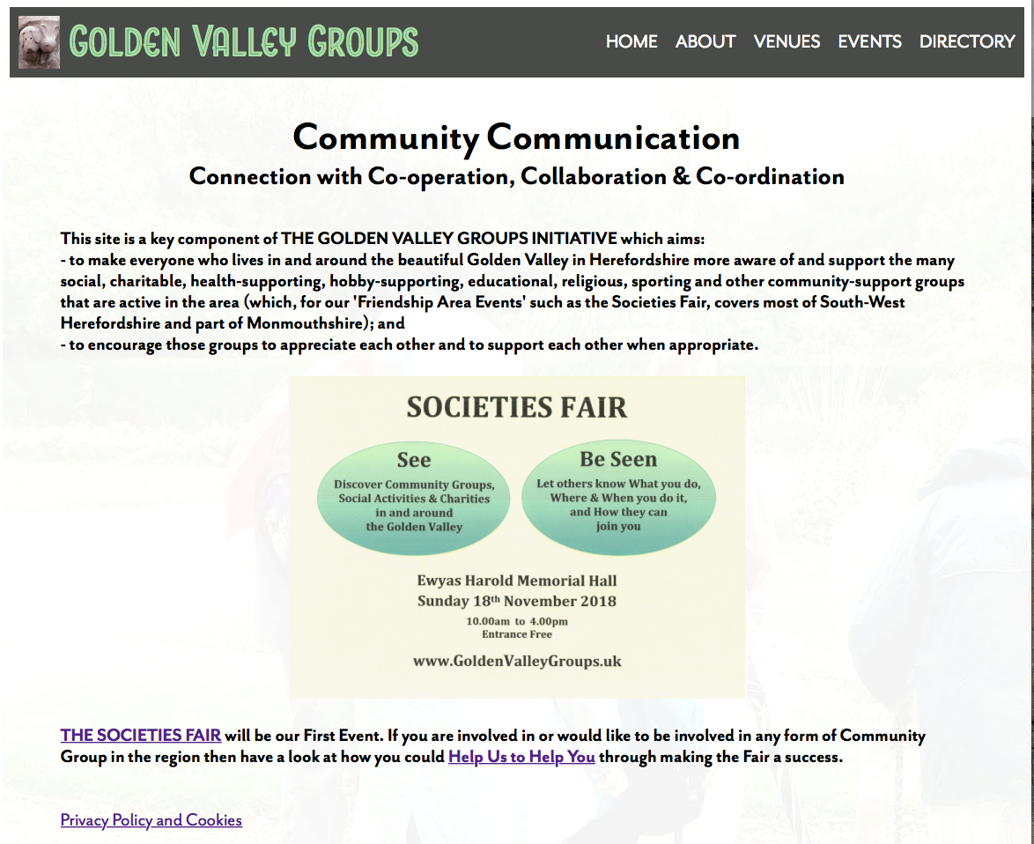
The Societies Fair 2018 is GVGI’s first Event but it is not our first Production. That was our web site which reports what we are doing & why we are doing it: www.GoldenValleyGroups.UK.
The site also provides the Online Directory that plays a major role in our attempt to help publicise the Community Groups in our area. If what we are doing interests you, do have a good look around the web site. It is a key element of GVGI.

[Warning: Our web site is not one of those that is rarely changed.
In fact, it is tinkered with regularly– so don’t think you know all that it contains unless you have checked it recently!]

One reaction we received to our early posters about the Fair was that some people interpreted “in and around the Golden Valley” in a very narrow way, thinking that we are interested only in the valley itself plus, perhaps, people who live within 2 miles or so of it. That is not the case! However, that view made us think that, should the Operations Area referred to below grow a lot, we might have to change our name, replacing ‘Golden Valley’ with something still relevant to South West Herefordshire but not specific to one valley. Any suggestions?

We expect to operate within 2 main areas:

- Our ‘Friendship Area’. This is our wider ‘Communications Area’. It covers most of South-West Herefordshire plus a spur into Monmouthshire to include Grosmont. We aim to ensure that everyone in this area is aware of (and hopefully supports) the many Community Groups in it. This area applies to our Societies Fairs and our Online Directory. It will probably also apply to certain of our Discussion Groups.

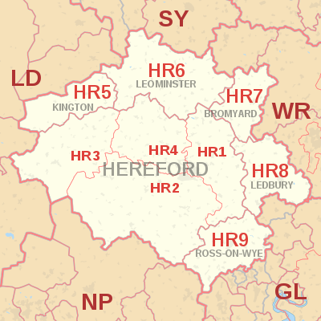
- Our ‘Operations Area’. This is where we hope to help some Community Groups develop closer ties with each other so that they benefit from Co-operating with each other (and possibly even Collaborating & Co-ordinating). This will start with a small ‘Core Area’, just part of the Golden Valley with those nearby hamlets & villages that want to be involved. If that goes well then we will think of expanding the area (albeit never beyond the Friendship Area). If it fails then “So be it”. There is no harm in trying and there is potentially quite a lot to be gained if GVGI succeeds!

COMMUNITY SPIRIT is surely a great thing. It leads to voluntary work without which many people would be much worse off. It often depends on building a sense of Community Identity that can resonate with people’s needs for Personal Identity. However, Community Identity is not always a good thing as it can lead to the exclusion of others, and sometimes unnecessary competition with others, and even the demonisation of others. Being only human, there are limits to how broad a spectrum of people any of us can associate with.
Why do we mention this? Because, whilst a lot of people have welcomed our wish to help support co-operation between our local villages, some have not, perhaps because they think we wish to intrude in their affairs. That is not the case! GVGI was started only because a need was identified & confirmed and there was a sense of obligation to do something about it. The smaller that need proves to be, the happier we will be!

GVGI will evolve over the next few years but, unless a good number of people join in and add momentum to it (something which would be welcomed but which is thought of as probably unlikely), or something else unexpected happens, it will be allowed to fade away after that. Our ambitions are merely:
- To hold another two Societies Fairs, probably in 2020 and 2022, both hopefully being significantly superior to our 2018 ‘trial & taster’ not least because we will no longer have to introduce ourselves ‘from scratch’ and we will have had much longer to prepare for them!
- To help a number of community groups develop long-term relationships with other groups that prove to be beneficial to everyone. They will have to do the relationship-building themselves. We simply aim to help smooth the way towards that. Our initial steps for that will be to hold a number of Discussion Groups whose initial purpose will be to clarify what is needed. We have a number of thoughts about that (see ‘Ideas’ on page 10) but know that we must first get feedback from others on them (see ‘Surveys’ on page 27) before they are taken further.

If you are interested in what we are doing, keep an eye on our web site at www.GoldenValleyGroups.UK … and contact us.

HALE THE HALLS!

At the beginning of 2018, when thoughts about developing GVGI were germinating, our appreciation grew of the roles played by the many halls in our part of the world. Many of them are not just useful facilities but are the Centres of Community Life. Without them, many communities would be diminshed.
We often refer to “Halls” when we should really be referring to “Venues” as many of the places which play a major role in Community Life are not halls but pubs, schools & similar places that have roles other than just allowing locals to use their facilities. We could have called this article “Venerate the Venues!” or something similar but “Hale the Halls!” just won the vote.

Too often the negatives in this world are focused on and the positives forgotten. If you are prone to cynicism & scepticism, just think about what some people do for others without seeking any reward. There are good people out there as well as baddies – and you will find some of them (the goodies, we mean) behind the scenes at our local halls. They are not appreciated as much or as well as they should be!

Many of those who run our halls are in much the same position as many of those who run our charities and other community groups. They volunteer to help and then get sucked in to doing more than they had originally intended to do. All too often they are stretched and so they focus on what has to be done in the short-term and forget to look up and see that there are others around who could help them do what they need to do. Indeed, the main inspiration for GVGI came when it was realised that some people were struggling to get people to their events but had not thought of using their local Community Transport charity whose main purpose is to help people get to where they need to go! Of course, that form of transport may not suit

everyone, and that particular charity may not always be able to help, but the simple fact that they had not even thought of asking the charity was, we thought, surprising. GVGI was formed largely to make it easier for the organisers of halls and other community groups to find out what the other groups around them can do to help them.

Within days of its creation in February 2018, we made it clear in our web site that GVGI is committed to keeping the following in mind:
- Most venues want to keep their independence.
- Some venues will not want any help from us at all.
- Our ideas should save time & energy, not cost them.
- Our ideas should generate more money than they cost.
- We should Keep It Simple and Keep It Friendly.
- The Best can be the enemy of The Good but ...
- Nothing ventured, nothing gained.
- NEVER CRITICISE A VOLUNTEER!
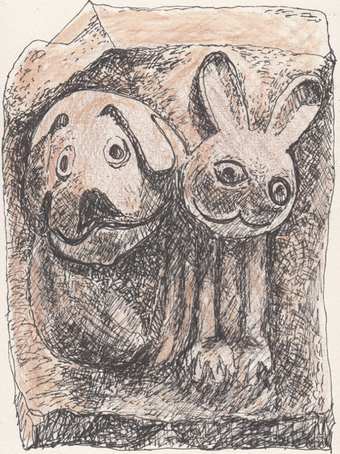
We repeat the above here because we have found that there are people around who are jealous of their independence, are proud of what they have achieved, and feel no need to involve anyone else. That is fine with us. We respect that and are interested only in trying to make it easier for those who do want help (and there are quite a few around) to obtain that help. We do not presume to be able to help them ourselves, only to facilitate contact & communication between relevant parties to make it easier for them to find help. Our ambitions really are that modest. Neverthless, they may lead to some good so we think it all worth a go – and we would welcome the support of others so that we can support those who support others. We hope that makes sense!

As at 13.11.18, the Venues section of the Activities Index in our Online Directory lists 35 places of which the following 32 are also listed in Herefordshire Council’s list of Community Halls. Although we may yet reduce this list, these are the halls that we are presently viewing as long-term targets for the 3Cs project we mention in our web site (that seeks to promote Co-operation, Co-ordination and Collaboration between venues). Do let us know if you think we have missed one out. If we have, please accept that we have done that accidentally, not deliberately!
Abbeydore, Allensmore, Bacton, Bredwardine, Callow, Clehongher, Clifford, Craswall, Dorstone, Eaton Bishop, Ewyas Harold, Garway, Hardwicke, Kilpeck, Kingstone, Little Birch, Little Dewchurch, Llanwarne, Longtown, Madley, Michaelchurch Escley, Moccas, Much Birch, Much Dewchurch, Orcop, Peterchurch Hub, Peterchurch Hall, Preston-on-Wye, Rowlestone, St. Weonards, Vowchurch & Turnastone, Walterstone.

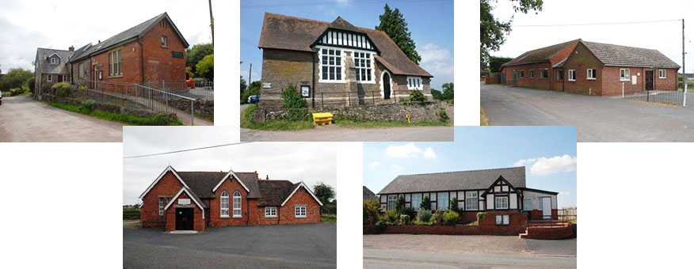

Over the next few years, we will probably produce a number of booklets & leaflets on various matters and expect that, in several of them, we will provide one or more short features on some of these halls and other appropriate venues. We start off that series with our host for this Societies Fair: Ewyas Harold Memorial Hall. There were other candidates, Peterchurch Hub, Dorstone Front Room & Care Herefordshire came to mind, but they are relatively new, their founders are still active, and their stories are still well-known. The story of Ewyas Harold Memorial Hall is fading from people’s memories. It is worth reminding people of it.

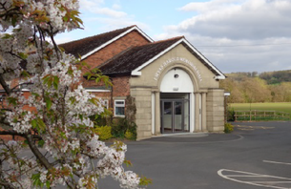

EWYAS HAROLD MEMORIAL HALL, HR2 0EL
The following borrows a lot (mostly shown in quotes) from a paper kindly provided to us by Ann Bradley, a key member of the Hall Committee at Ewyas Harold Memorial Hall. The core of that paper may be found in ‘Brief History about the Hall 1945-2016’ which is in the ‘About the Hall’ section of ewyasharoldmemorialhall.wordpress.com.
It is sometimes forgotten that The Ewyas Harold Memorial Hall was not developed solely by or for Ewyas Harold. Ewyas Harold was only one of the four parishes that worked hard to get the hall built. The others were Dulas, Kentchurch and Kenderchurch. In 1945 these parishes, like many others around the country, “wanted to do something to show their gratitude to those who had fallen in the World Wars.” They decided that a Memorial Hall would be a fitting tribute. It took them ten years “of very hard work”. The hall was built on land kindly donated by Mr E.R. Wright. It was opened on Easter Sunday, 10 April 1955. To raise the funds, …

“They began with a collection of pennies starting at the door of the Red Lion which was where the organisers usually met. The main event of the year took place over the August bank holiday. In 1946, the first such event, a staggering £483 was raised, equivalent to many thousands today. In 1947 it was decided that there would

be a repeat performance. The format of a whist drive; dance; choral festival; side shows; sports including boxing, darts, and bowling; flower show; gymkhana or pony racing was developed.

The programme varied little over the next 16 years. There was always a Carnival Queen, chosen by a husband and wife team at the May dance. The carnival procession often started from Station Approach in Pontrilas. Returning servicemen became heavily involved with the fundraised activities as were the children of the village, supporting the committee in achieving the goal of the community. … …

Following the opening of the Hall not all the members of the original Committee wanted to continue. The new Committee faced the difficult task of completing the Hall with debts to pay off. The final builder’s (Mr Bowyer) account was settled in 1961, with a bank loan and over 137 events organised by the committee with over 16,000 people attending them.”

This was clearly a Community Project of great significance. That so many of us today take the Hall for granted, particularly those who were not around (in these parts) in the 1950s, is a good example of how easily such great efforts are forgotten. However, at least the main purpose of the Hall, to act as a Memorial to those who fell in the World Wars, is preserved in its name. But there is more than that: that the hall has been extended in recent years and is thriving, being the centre of many activities, is testament to the effort that has been put in since the 1950s and is still being put in to this day. That Community Project Spirit is alive and well! It is just that it is now reliant on only a few individuals who give up a lot of their time to keep it going. That there are others up and down the country who do similar things does not take anything away from what these people do. It is a reminder that, as was said at the beginning of this article: “There are good people out there.”

IDEAS

If you go to GVGI’s web site at www.GoldenValleyGroups.UK, you will find that the About page has a link to the (slightly hidden-away) Ideas Section where we identify the Ideas (thoughts, suggestions, etc.) which have influenced GVGI’s development to date and show what we are thinking about for the future. As at 13.11.18, there were 10 of them, as follows:

Idea#01 | The thoughts that led to 'The Golden Valley Groups Initiative' and hence to the development of this site.
Idea#02 | The idea of holding a 'Societies Fair' in 2018 ... and, if that goes well, from time to time thenafter.
Idea#03 | Much of what we want to do can be achieved through simple advertising & marketing campaigns.
Idea#04 | Transport support is one of the most important community-support activities.
Idea#05 | We need to be both creative & co-operative to make the most of our venues (halls, pubs, etc.).
Idea#06 | We could facilitate the development of some kind of a Golden Valley Venues Network or Forum.
Idea#07 | Competitions can be good for getting things done and for generating fresh ideas.
Idea#08 | We, and the groups we are trying to help, will need expert advice & guidance from time to time.
Idea#09 | We should make it easier for Local Government to help us!
Idea#10 | We could support the development of a local U1A and U2A (or equivalent).

The influence of these is clear, the first 2 somewhat obviously. Idea#03 just emphasises the importance we put on the worth of Communication (although we have a lot to learn on that front). As for Idea#04, see the next page. Ideas#05 #06 #07 #08 & 09 will almost certainly lead to the holding of a number of Discussion Groups (though we need first to get feedback from a number of surveys – see page 27). Idea#10 was the inspiration for the article on page 16. Sometimes Ideas have Consequences!

COMMUNITY TRANSPORT

Recognition of the importance of Community Transport, and the need for our communities to support it, provided the original inspiration for GVGI. The following is by Roger Bradley, Chairman of Dore Community Transport.
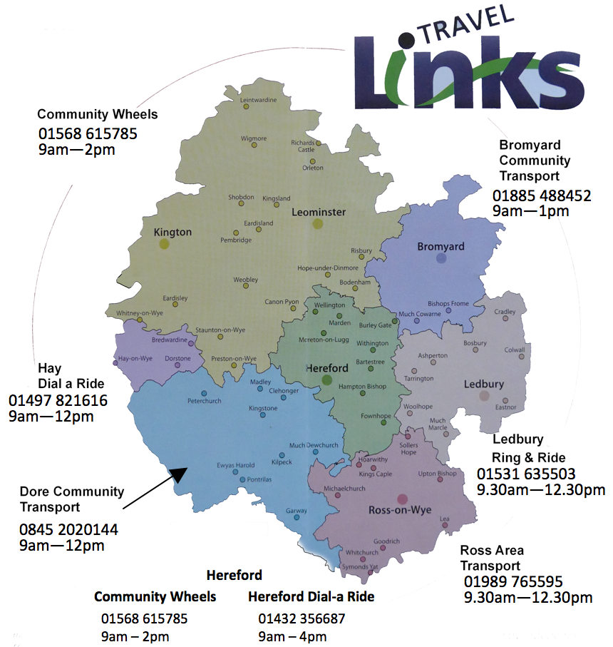
Herefordshire is one of the most sparsely populated counties in the country and, while that means Hereford is a great place to live, it brings with it problems. A major issue for many people living in isolated areas, and particularly for the older or more infirm members of our society, is access to affordable transport. This is where Community Transport fits in and in this area Herefordshire is particularly well served. The whole of the county is covered by seven dedicated Community Transport groups, as shown in this map.

In addition to this numerous other charities also provide transport as a part of their other activities.

The first group set up in Herefordshire was Hereford Dial-a-Ride, back in 1987, and other groups followed with Dore Community Transport completing the picture when it came into being in 2000.

Over the years these seven groups have grown. Whilst they do not all operate in exactly the same way, they all provide a door to door service for anyone in their area who needs transport but has no access to public transport or cannot use it for whatever reason. Vehicles used to provide this transport range can be mini-buses, MPVs and private cars. What ties all of them together is that they are all operated by dedicated volunteers and staff and are charities or not-for-profit organisations.

Often our passengers are older or have disabilities, but Community Transport is much broader than that. We carry people of all ages, take them to all sorts of places (definitely not just to Hospitals) and try to keep our costs as low as we can. All of the groups rely heavily on a relatively small group of very committed volunteers plus a few equally committed staff, and the reason we all volunteer is to make life easier for people who would otherwise be very isolated.

So, how does it work?
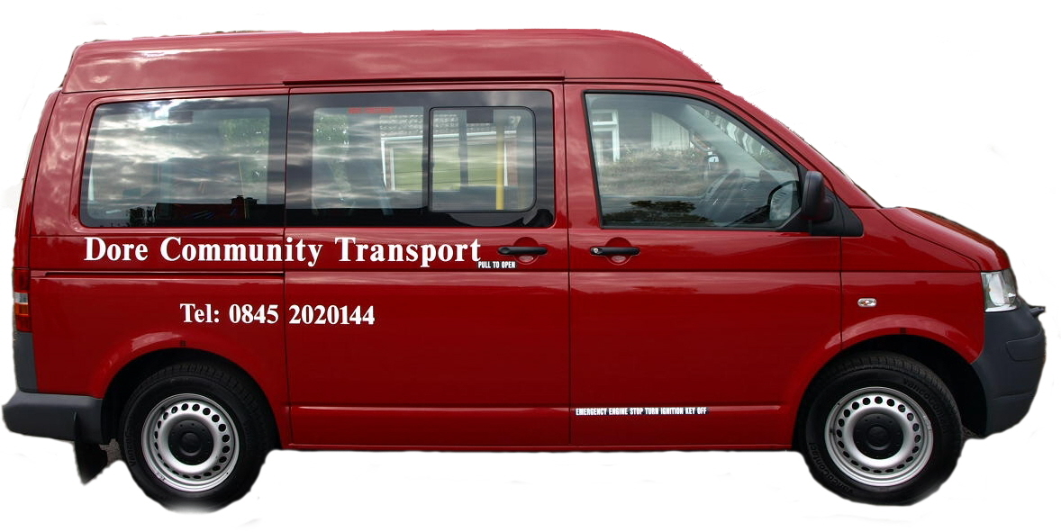
What follows is how Dore Community Transport operates, but you will find the other local groups will be much the same.

Who can use Community Transport?
The short answer to this is anyone who has no other alternative transport that they can use. We carry individuals and groups, old and young for one off trips or regular journeys. We have vehicles adapted to carry passengers confined to wheelchairs and our drivers are trained in making sure the wheelchairs are properly secured.


Where can you go?
No, unfortunately we can’t go everywhere, but provided it’s within the area we cover you can go anywhere you want. Dore Community Transport’s area covers South West Herefordshire but we regularly go further afield within the county, and can go further if we have a vehicle and a driver. So, for example whether it’s to …
Shops Lunch clubs
Hairdressers Theatre
Doctors Visiting friends
Hospitals
… we are happy to take you there.

When can you travel?
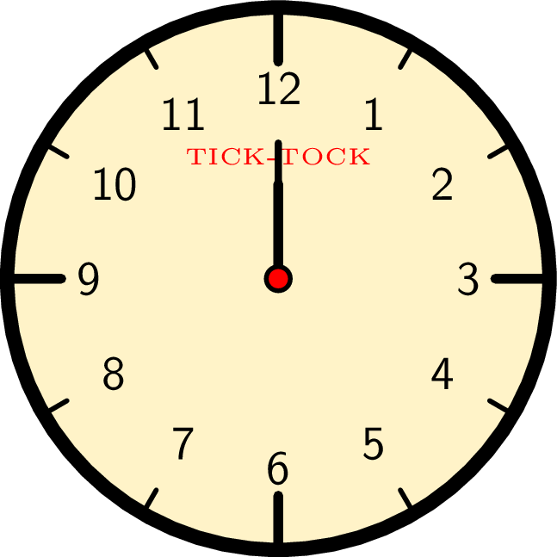
Dore Community Transport’s standard operating hours are 9am to 5pm Monday to Friday but are flexible about the start and finish times. We don’t normally operate at weekends but we can if we can find a driver.

The Process of booking

The first step is to phone your local office i.e. the office covering the area in which you live. For us that’s on 0845 2020144. We need a minimum of 2 days clear notice of travel and preferably a day more so that will can plan our journeys and let the drivers know what they have to do. We man our phones between 9am and 12noon, (other group’s hours are different) but you can leave a message outside these hours. We will let you know if we can accommodate your journey; when we will collect you; how much it will cost and who your driver will be.

The Journey

We will pick you up, as arranged, usually at your door, and will offer assistance if it’s needed. You may find yourself sharing your journey with someone else, and we have had a few friendships start up this way. You may also find yourself having a short tour of the countryside if we have other passengers to collect or deliver but we will try to keep this to a minimum, although again some of our customers quite like a ride round. When we pick you up for the return journey we can usually help with your shopping if you need it and again when you get home.

You can be assured that your driver will have been security (DBS) checked, and, if you travel with us regularly you will probably get to know your driver quite well.

Running a Community Transport group.
There are two main challenges to running a Community Transport group, one is finding the money and the other is finding volunteers.

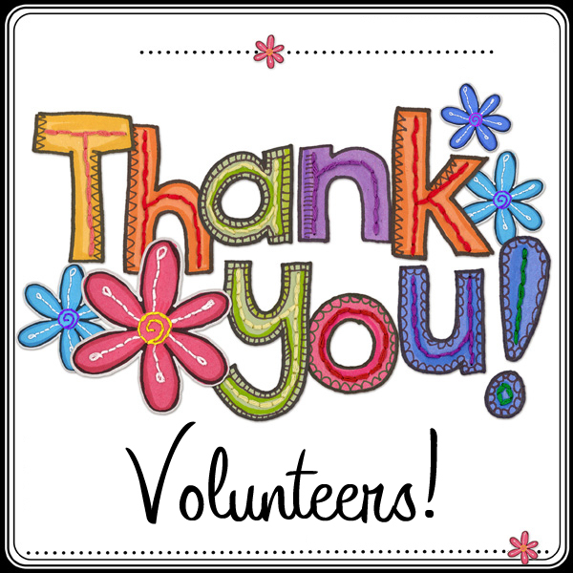

Speaking for Dore Community Transport, we are always amazed at how well we are supported by our local community. We get financial support from Herefordshire Council, and from many Parish Councils but the support we get from the local community, from clubs, pubs and groups, as well as from individuals is really appreciated, not just because we need the money, but also because it really does help to know that the service we provide is appreciated.
We can’t say thank you enough.

The other challenge, as always, is recruiting volunteers. It’s not always easy to volunteer, there are lots of conflicting pressures on people’s time these days but we try to make volunteering as easy and as enjoyable as possible. As a volunteer with Dore Community Transport can help as often as you wish, when it suits you. You can drive your own car (for which you will be reimbursed) or one of the group’s own vehicles.

The rewards you will get come from the passengers, who will constantly remind you of how grateful they are for the help you give them and what a difference you are making to their lives. You will also have the satisfaction of knowing that, through your efforts, people can maintain their independence, continue a social life and, in the extreme, be able to continue to live in their own home for a few years more. Testament to the pleasure and satisfaction that volunteering brings is the fact that once we recruit a volunteer they stay with us for a long time.

So if you are interested in using Dore Community Transport give us a call on 0845 2020144 between 9am and noon Monday to Friday and we will see what we can do to help. If you run a group and think we might be able to help it’s the same number but please bear in mind that the maximum we can carry is seven people.

The numbers for all of the Community Transport groups are on the map at the start of this article. Don’t forget that there are also other groups who offer transport as part of their activities such as Peterchurch Hub, Care Herefordshire and OWL.

THE THREE AGES

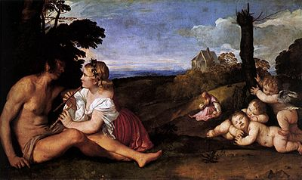
In Titian’s masterpiece ‘The Three Ages of Man’, childhood and manhood feature prominently whilst old age is in the background, difficult to see. That was possibly a fair reflection of what things were like around 1513. Nowadays, it is arguable that the elderly grab at least as much attention as children do whilst younger adults are often taken for granted and are left to their own devices (sometimes literally as well as idiomatically).

- Many people are good at socialising but many are not or do not have good opportunities to socialise.
- Many people enjoy the benefits of Social Media and the Internet but many do not or do so for only part of the time.
- Many parts of the region we live in are well supported for social activities & gatherings but many are not.

The above leaves many people seeking means of meeting others in similar circumstances or with similar interests. Nowadays, those who have retired (full or part-time) are reasonably well supported on such things. Indeed some of those who benefit from using groups such as U3A & Probus find themselves having a better social life than they have ever had before. By and large, children are well supported for socialising (although there are certainly some who feel otherwise). There are some Youth Groups in and around our region (although we at GVGI are not yet clear how wide their coverage is). That leaves those who are at work or are trying to find work. Many do very well. Many do not.
William Shakespeare identified Seven Ages of Man: the infant, the whining schoolboy, the lover, the soldier, the justice, the old, and the senile. U3A identifies just three: before career, during career, and after career.

On page 10 we refer to the fact that our web site reports various ideas that are influencing how we are developing GVGI. Idea#10 suggests that it is at least worth having a think about developing some form of network to support the social lives of those who have left school and are either at university or college or are in work (whether alongside others or at home) or are looking for work. At this stage this is little more than an Idea and we do not yet know whether or not others (apart from the few we have talked it over with so far) will agree that it is worth pursuing. Consequently, it is one of the matters we are covering in a Survey (see page 27).

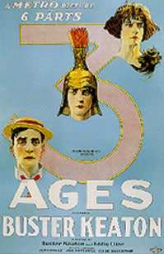
Buster Keaton’s film ‘The Three Ages’ (made in 1923) suggested that Modern Man was much the same as he had been in both Prehistoric and Ancient Roman times. The world has moved on since the 1920s but that observation remains true even though Life for the Average Person living in Herefordshire has probably changed more in the last 110 years (going back to just before the First World War) than it did in the preceding 300 years. Television, the Internet, and Social Media have truly changed our lives (as has the motor car, etc. etc.). Will Virtual Living be the next big thing or is that just a variation of the escapism provided by reading a novel or watching a film? Who knows?!
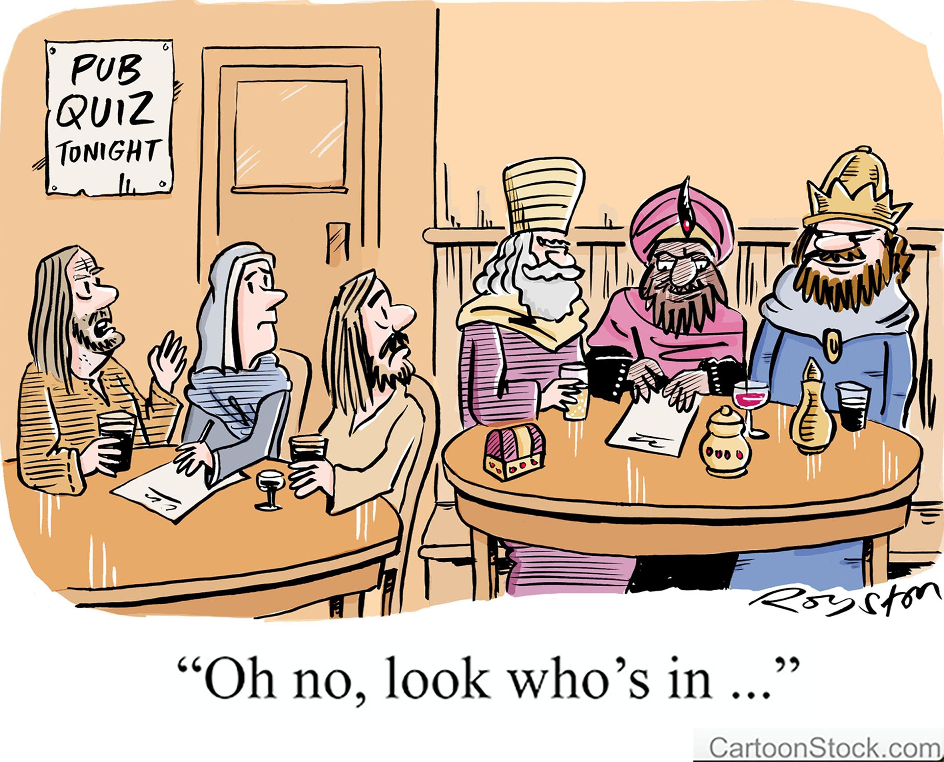
What does seem to be clear is that Mankind is and probably will always be a Social Animal. Without positive interaction with others, Life can become dull however much we have other distractions. That is why we view informal gathering places, such as pubs, as often even more valuable to Society than village halls. If Idea#10 comes to anything, it will probably produce a number of informal gatherings in pubs.
[Note from Peter. Unless I have to drive, mine will probably be a glass of Rioja (red or white) or a Butty Bach. Thanks!]

SOCIETIES FAIR 2018 - PARTICIPANTS

Stall
C | Abbeydore Ladies Guild
A | Abbeydore Village Hall
D | Black Mountains Herefordshire Wildlife Trust
G | Borderlands
I | Care Herefordshire
B | Community Catalysts
B | Community First
A | Dore Community Transport
H | Eaton Bishop Village Hall
F | Ewyas Harold Festival of Arts
F | Ewyas Harold History & Archaeology Society
A | Ewyas Harold Memorial Hall
D | Ewyas Harold Twinning Association
E | For People and Planet
A | Friends of Dore Abbey
F | Garway Heritage Group
A | Golden Valley Groups Initiative (GVGI)
B | HVOSS
B | Healthwatch Herefordshire
E | Hereford Searchers
H | Kilpeck Village Hall
F | Longtown & District Historical Society
F | Madley Craft Group
C | OWL Good Neighbour Scheme
G | St. Michael’s Hall, Ewyas Harold
A | Scouts
C | U3A (University of the Third Age)
C | Walterstone Village Hall
C | WEA (Workers Educational Association)
C | WI (Women’s Institute)
B | WISH

Providers of posters, leaflets and/or flyers (EH = Ewyas Harold)
Age UK, Arts Alive & Flicks in the Sticks, EH Community Library, EH Methodist Church, EH Walkers, Golden Valley Bowls Club, Golden Valley Probus Club, Grosmont Gardening Club, Herefordshire Rural Hub, Koffi Pot, Let’s Move!, Peterchurch Hub, Rowlestone Guild.

These will probably be placed either at Stall A or in the Lounge.

SOCIETIES FAIR 2018 – LAYOUT OF THE STALLS

The following was prepared a few days before the stalls were set-up. It provides a rough rather than an exact guide to where participants may be found and the sizes & positions of tables.

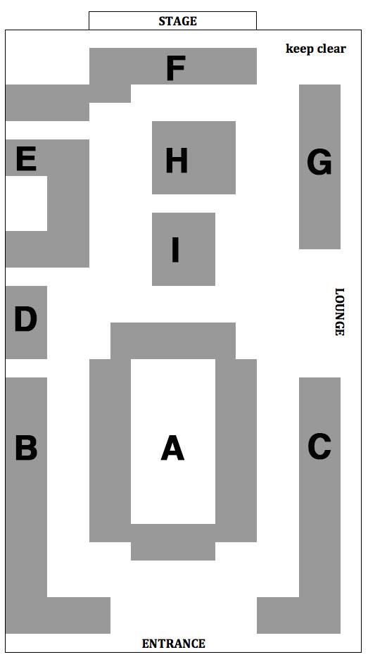

SUPPORT FOR THE SUPPORTERS

Running any kind of project can throw up daunting challenges. Fortunately, there are several experienced people around who are willing to help, often for Free, but (of course) you need to know where to find them. With features by Tess Brooks, Joy Harvey, Richard Timney and Carla Preston respectively, we are pleased to draw your attention to 4 impressive organisations that help community groups: Community Catalysts, HVOSS, Community First and Herefordshire Council.



Community Catalysts is a social enterprise working across the UK to try ensure that people who need care and support to live their lives can get help in ways, times and places that suit them, with real choice of attractive local options. We have many years of experience helping local people nationally to use their energies and talents to deliver sustainable community enterprises that can support other local people, creating jobs and volunteering opportunities.

The Enterprising Communities Project is a new initiative delivered in partnership between Herefordshire Council and Community Catalysts. The project, which will run until January 2020, aims to stimulate the development and growth of community enterprises to help support people who are lonely and isolated and to increase their community wellbeing.

Small community enterprises often struggle to find the information and help they need to cope with changes in the care world, regulation, legislation, marketing their service, knowing who to talk to, or a multitude of other issues.

Our project has a focus on community enterprises that support people who need some care or help to live a good life and:
- provide care or support services to people who are older, have a disability or illness or are vulnerable for some other reason
- have 8 or fewer full-time equivalent staff or volunteers
- are totally independent of any larger organisation
- could benefit from some support or advice.

It doesn’t matter if your organisation is a charity, voluntary organisation, social enterprise, small business, cooperative (or any other structure you may use) as long as it meets these criteria you are able to access help and information from the coordinator. The project also provides help and support to existing community enterprises which are having difficulty or who need support.

The project can provide help and support around a wide variety of topics from developing your idea, marketing, funding, GDPR, writing policies and procedures, becoming and employer, connecting you to professionals who might make referrals to your service or activity, websites, technology, full cost recovery and sustainable models, recruiting volunteers or staff and many many other things.
If you want to find out more about Community Catalysts in Herefordshire, please get in touch with Tess Brooks either by email (tess.brooks@communitycatalysts.co.uk) or phone (07584 474542).



What is hvoss?
Herefordshire Voluntary Organisations Support Service

What does it do?
hvoss provides support, assistance and guidance to charities, community groups and voluntary organisations based in Herefordshire.

hvoss also:

Operates the Community Wheels transport scheme. Based in Leominster, it provides door to door travel for people living within the catchment area, without access to a car or public transport.

Works with the NHS on Social Prescribing (see opposite).

Talent Match is based in Hereford and Telford, it provides support for 18 – 25 year olds who are seeking employment.

No Wrong Door (NWD) is a Hereford based hub for young people aged 11 – 25. The team provide a non-judgemental, safe space and advice via their Partner Agencies.

Building Better Opportunities (BBO) is an EU funded project to support people aged 19+ who are not working or volunteering. The team are based at Berrows Business Centre in Hereford.

Volunteer Bureau is open to all residents of Herefordshire who want to find a volunteering role in the county. It can be accessed via the hvoss website by clicking on the “I want to Volunteer” button at the bottom of the home page. It is free to use.

Local groups can also upload their voluntary roles buy clicking on the “We involve Volunteers” button at the base of the hvoss website home page. It is free to use for everyone.

BUILDING A VIBRANT AND EFFECTIVE VOLUNTARY SECTOR IN HEREFORDSHIRE




Social Prescribing for Better Health and Wellbeing

Social Prescribing helps you to explore extra services that may support you to improve your health, wellbeing and independence.

How does it Work?
A member of your GP practice team may suggest a referral to the Social Prescribing service. One of our Social Prescribers will contact you to find out what you are interested in, tell you about local services and activities that are available, and help you to access them.

Together you will be able to:
- Explore what is important to you and your wellbeing
- Identify local activities and services that you could benefit from
- Increase support and encouragement to start using services that can assist you

The Social prescriber is:
- Someone who can support you
- Talk to in confidence
- Someone who is helpful, practical and who will not judge
- Someone who can advise and help you decide what you would like to do to improve your wellbeing, independence and health.

Social Prescribing can link you with many services in your community to help. These may include:
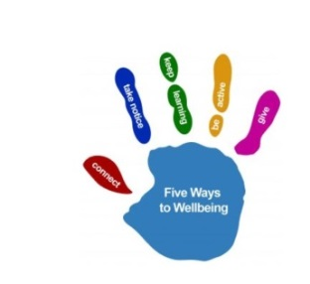
- Arts, music, outdoor activities
- Healthy lifestyles and active support
- Counselling and support groups
- Financial support and advice
- Employment, training and volunteering
- Learning and education
- Local groups and activities
- Accessing specialist support and services



Community First was set up in the 1920s as the Rural Community Council for Herefordshire & Worcestershire. It is now an independent charity that aims to strengthen rural communities in its region. It is part of the network of charities known as ‘Action with Communities in Rural England’ (ACRE) which liaises on various matters with DEFRA (The Department for Environment Food & Rural Affairs), regional development agencies, etc.. The following introduces Richard Timney who is Community First’s advisor on Village Hall affairs.

Since 2011, Richard Timney has been helping village hall management committees in Herefordshire and Worcestershire to understand their roles and responsibilities and to take action to improve their buildings and tackle any problems.

Richard advises over 340 halls and there is little he hasn’t been asked from “Are there regulations that apply to using wooden toilet seats in a village hall?” to the more obscure “What do we do if moles from our land migrate to a neighbour’s garden?”

Many village hall issues arise from misunderstandings about the powers of a village hall management committee, the role of the Parish Council and the balance of responsibilities between hirers of halls and the venue. Such disputes can become very troublesome sometimes setting neighbour against neighbour.

But problems are not the bulk of Richard’s work – building improvement projects, developing new activities and sharing good ideas – play a vital role. Including new halls being built, new toilet and kitchen projects, setting up art classes, cinemas, coffee mornings and reinvigorating management committees – there is much to celebrate.

Our local County Council faces many complex challenges with a tight budget. Overall they do a pretty good job. Those who criticise it should let us know how they would do better! We hope in 2019 to hold Discussion Groups to report on what they offer and to work out how ‘We The People’ can help them to help us. [Idea#09 in our web site refers to this.]
The following was kindly provided by Carla Preston of the Council’s ‘Adults and Communities’ directorate.



Funding advice and business grants
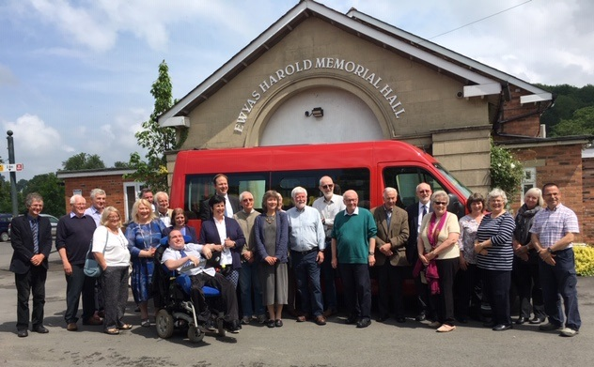
The council has a Funding Update section on its website where you can find information about a range of funding opportunities available locally and nationally for community groups and the voluntary sector. The opportunities tend to be for new projects rather than existing ones; although many existing groups and societies find that their activities meet the criteria of one or more of the funds. You can access this information through WISH (www.wisherefordshire.org) or the council’s website (www.herefordshire.gov.uk).

Dave Tristram, funding and enterprise officer (community and voluntary groups), is available to advise and support groups through the funding application process. He can be contacted on 01432 260636 (dtristram@herefordshire.gov.uk).

Social enterprises

Social enterprises are businesses set up to tackle social problems and/or improve the environment. They operate in all areas of business. The council can

help with advice and support to develop a social enterprise business or charity, advise most appropriate legal structures, identify and develop income streams and sources of funding and finance. They are great for groups operating as part of the community who wish to deliver services to benefit local people.

Elaine Edwards, funding and enterprise officer can be contacted on 01432 383030 (elaine.edwards@herefordshire.gov.uk).

Promoting your events and activities on WISH for free

WISH is Herefordshire’s online service for wellbeing information and signposting to local services, groups, events and activities across the county. It’s a community website that’s free and easy to access and can be used by residents and professionals who support local residents, like GPs, social workers, charities and local community groups. The aim is to help people stay independent, happy and healthy by providing them with information when they need it, and to find out about events, activities and support in their community.

We want to make sure that the local information on WISH is as comprehensive as possible and would like to invite clubs and societies in and around the Golden Valley to join WISH by either registering as a provider of services or adding events to the What’s On calendar. You’ll be joining over 600 local groups and services registered on WISH, which is used by thousands of Herefordshire residents each year. It’s quick and easy to do and doesn’t cost anything.

You can find out more and see how WISH can benefit your enterprise by visiting the WISH website (www.wisherefordshire.org). Alternatively, contact Carla Preston on 01432 260098 (cpreston@herefordshire.gov.uk) who will be happy to help.

SURVEYS

We are using the term “Surveys” in a generic way to describe a number of different approaches & occasions that enable us to find out how things really are ‘on the ground’ so that we do not rely too much on presumptions, assumptions, and the personal opinions of just a few. Some surveys might best be described as formal questionnaires, others as informal chit-chat. Their collective purpose is to enable us to prioritise our efforts so that we do not waste our or other people’s time but focus on a few of the things that people actually want.

Whilst preparing for the Societies Fair has been our focus for the second half of 2018, in 2019 we expect to spend quite a bit of time discussing, planning & organising Discussion Groups. These will often be simple meetings of people wanting to discuss specific topics, possibly with an expert speaker or two. To start the process of finding out whether or not there is meaningful demand for this, we have prepared a leaflet for distribution at this Fair called ‘Survey #1’ and would be grateful if you would provide us with feedback on it. It may also be found in our web site.

Possible subjects for Discussion Groups include:
* The development of a loose network or forum of groups that want to try to improve & develop the ways they co-operate with each other [Idea#06, see page 10.]
* If this works well, it could lead to sharing responsibilities for a variety of things such as co-operation with the organisation of something like a ‘Golden Valley Show Week’, coordinating events so that venues support each other rather than compete with each other, and collaborating on maintenance & similar matters to help reduce costs. [Idea#05]
* Using competitions to generate ideas or complete tasks. [Idea#07]
* Helping groups get expert advice & guidance. [Idea#08]
* Working constructively with Herefordshire Council. [Idea#09]
* Supporting the social lives of those who have not yet retired. [Idea#10, see the article on page 16.]

DIRECTORY

The following pages provide extracts from the Online Directory at www.GoldenValleyGroups.UK/directory.html as at 11th November 2018. The groups that are participating in this year’s Societies Fair, even if only by way of having flyers or leaflets to view, are shown below with and are listed on page 18 (in the centrefold).

The Directory is still at an early stage of its development. There are bound to be quite a number of errors (particularly where we have relied on data found in web sites that may not have been kept up-to-date). There are certainly many omissions. However, we had to start somewhere. We would welcome friendly & constructive corrections & suggestions.
Remember: It is all ‘E&OE’ and “Never criticise a volunteer!”

Developing the Online Directory is important to GVGI as it is our main way of helping “to improve the awareness of The General Public of all of the many community-supporting groups that are active in and within easy driving distance of the Golden Valley in South-West Herefordshire” (from the About Page of our web site). Your help in making it do that really would be much appreciated!

Caveat regarding the Village, Parish & Community Halls identified below as Venues (“VEN”, all showing the symbol)
The information on the activities supported and contact details have been taken from the Herefordshire Council’s Online List of Community Halls (see Hereford Community Halls below) with only an occasional correction. Making it easier for the halls to keep online details such as these up-to-date (never an easy matter) could be discussed at one of our Discussion Groups in due course.

Identification of links given in the Online Directory.
= own or related web site = own or related Facebook page
= Herefordshire Councils list of Community Halls
= WISH’s web site = contact via email only

Key
ACD = Art, Craft & Drama; CHA = Charitable; CHI = Children, EDU = Educational; ENT – Entertainment; FAR = Farming Community; GPM = Group Marketing; GPS = Group Support; H&W = Health & Wellbeing; HOB = Hobby; LSK = Life Skills; MUS = Musical; REL = Religious; SOC = Social; S&E = Sport & Exercise; TRA = Transport; VEN = Venue; YGP = Youth Groups.

Abbeydore Ladies Guild |  | SOC |  | -
An independent women's group that meets at the Abbeydore Village Hall on the 1st Thursday each month. [01981-240583 or 01981-240508]
Abbeydore Village Hall |  | VEN
Council site (07.11.18): Contact: 01981-240464.
Activities supported include Playgroup, Fundraising, Women's Guild.
Age UK (Herefordshire & Worcestershire) |  | CHA
Age UK was formed in 2009 when 2 earlier well-known charities (Age Concern & Help the Aged) were combined. It is now the UK's largest charity working with older people. [03330-066299, www.ageuk.org]
Air Cadets (Ewyas Harold) |  | LSK, YGP
The Ewyas Harold Group has its own hall just behind the Memorial Hall.
Allyana Bellydance – see Let’s Move!
Allensmore Village Hall (Pateshall Hall) |  | VEN
Council site (07.11.18): Contact: 01432-357472. Activities supported include WI, Keep Fit, Garden Club, Social, Fundraising, YFC.
Arts Alive & Flicks in the Sticks |  | ENT
Locations within our region include Dorstone, Michaelchurch Escleyside & Garway. [www.artsalive.co.uk.]
Bacton Village Hall |  | VEN
Council site (07.11.18): Contact: 01981-240336. Activities supported include Social, Fundraising.
Bellringers |  | HOB, MUS
Black Mountains Herefordshire Wildlife Trust |  | CHA, FAR
Part of the Herefordshire Wildlife Trust based near Leominster (01432-356872]. Local contact: BMHWT@gvgi.uk. [www.herefordshirewt.org]
Book Clubs | EDU, ENT, SOC |  |  | -
There are many book clubs in the region but most of their meetings are held in private homes and so are by invitation only. To find a book club near you, ask at your local village hall or contact a group such as U3A or the WI.
Borderlands |  | FAR, REL
Provides “a confidential, listening ear offering pastoral support to farmers, farming families and agricultural communities”. [07958-591646 or 07531-676832. borderchaplain.org]
Bredwardine Village Hall |  | VEN
Council site (07.11.18): Contact: 01981-500155. Activities supported include Tai Chi, Feldenkrais, Village Market, Social Events, Children's Parties.

Brightspace |  |  |  | CHA
A not-for-profit organisation based in Hereford that aims “to enable people and communities to live sustainably." [01432-378409]
Brownies – see Guides Brownies & Rainbows
Callow Village Hall |  |  |  | VEN
Council site (07.11.18): Contact: 01432-279779.
Care Herefordshire | CHA, GPS, H&W, SOC, TRA, VEN
The impressive 'Social & Wellbeing' hub based at Pontrilas Post Office.
Charity Checkout (Herefordshire) |  | CHA, GPM, GPS
Part of a nationwide project to help people identify & support local charities.
Churches Near You |  |  |  | REL
A web site with a page for every Church of England church in the UK.
Clehonger Village Hall |  |  |  | VEN
Council site (07.11.18): Contact: 01981-251079. Activities supported include Playgroup, Keep fit, Yoga, Social, Fundraising, Brownies, Childrens Dance Club, Adult Ballroom Classes, GVCM Club.
Clifford Community Centre |  |  |  | VEN
Council site (07.11.18): Contact: 01497-831422. Activities supported include WI, Playgroup, Keep Fit, Social, Fundraising, Youth Club, Dance, Karate, Sunday School.
Community Catalysts |  |  |  | CHA, GPS
A Social Enterprise and Community Interest group. See page 20.
Community First |  |  |  | CHA, GPS
The advisory & support group mentioned on page 24.
Community Libraries |  |  |  | EDU, ENT
So far we have found that volunteer-run libraries are held in Dorstone, Garway, Ewyas Harold , Kilpeck & Peterchurch.
Community Wheels |  |  |  | CHA, TRA
The Leominster & Hereford Community Transport group operated by HVOSS, mentioned on pages 11 and 22.
Craswall Village Hall |  |  |  | VEN
Council site (07.11.18): Contact: 01981-510226. Activities supported include Fundraising, Young Farmers' Club, Over 60's Club, Social.
Dore Abbey – see Friends of Dore Abbey
Dore Community Transport |  |  | CHA, TRA
The Community Transport group that covers most of the area being considered by GVGI. See the article that starts on page 11.

Dorstone Front Room | SOC
The initiative that saved Dorstone from losing its local Post Office and then provided a friendly meeting place. [01981-550777]
Dorstone Village Hall | VEN
Council site (07.11.18): Contact: 01981-550280. Activities supported include WI, Toddler Group, Fundraising, Cinema, Youth Club.
Eaton Bishop Village Hall | VEN
Council site (07.11.18): Contact: 01981-250408. Activities supported include WI, Garden Club, Social, Square Dancing, PCC, Farmers Market.
Eat.Sleep.Live.Herefordshire | GPM
A guide to tourism and leisure activities in Herefordshire. [07713-243869]
Escleyside Hall – see Michaelchurch Escleyside Hall
Ewyas Harold & District Twinning Association – see Ewyas Harold Twinning Association
Ewyas Harold Baptist Church | REL, SOC
Ewyas Harold Festival of Arts | ACD
This group organises an annual showcasing of local artists.
Ewyas Harold Football Club | S&E
Based at the Recreational Ground. [07974-838104]
Ewyas Harold History & Archaeological Society | EDU, HOB
An occasional group that takes on interesting local projects.
Ewyas Harold Memorial Hall | VEN
Council site (07.11.18): Contact: 01981-240710. Activities supported include Women's Institute, Playgroup, Keep Fit, Social, Fundraising, Cinema, Community Access Point (CAP), U3A, Mat Bowling, Scouts Cubs & Beavers.
Ewyas Harold Methodist Church | REL, SOC
The church has a 'Pop In' open morning on the last Saturday of each month.
Ewyas Harold St. Michael’s Church | REL, VEN
Has a hall that is used for a wide range of regular activities. [01981-240574]
Ewyas Harold Twinning Association | SOC
The Association has a Friendship Pact with the village of Segonzac near Cognac, SW France. [twinning@gvgi.uk]
Ewyas Harold Village Web Site | GMP
Informative web site about local facilities and things to do in the area.
Ewyas Harold Walkers – see under Walking Groups.

Farming Community Network |  | CHA, FAR
A charity that supports farmers & families within the farming community through difficult times. [03000-111999]
For People and Planet |  | EDU, LSK |  | -
A local independent group formed by like-minded people keen to create a fairer society in tune with the environment. [sue@2youngs.co.uk]
Friends of Dore Abbey |  | ENT, REL
They support the Abbey not least through arranging concerts & fairs.
Garway Heritage Group |  | EDU, ENT
Exploring the local rich & diverse heritage. [garwayheritagegroup.co.uk]
Garway Village Hall |  | VEN
Council site (07.11.18): Contact: 01600-750664. Activities supported include WI, Keep Fit/Yoga, Cinema, social, fundraising, Library
Golden Valley & South Wye Magazine |  | GPM |  | -
(The) Golden Valley Bowls Club |  | HOB, S&E |  | -
Meets in the Memorial Hall on Monday mornings and Tuesday evenings.
Golden Valley Groups Initiative |  | GPM, GPS
See page 2 and elsewhere in this brochure.
Golden Valley News Magazine |  | GPM, REL |  | -
Golden Valley Probus Club |  | SOC
A social group for retired & semi-retired professional & business-men. One of the least formal and most active Probus Clubs in the country.
Good News Magazine |  | GPM, REL |  | -
Grosmont & District Gardening Club |  | HOB, LSK
Meets on the first Tuesday of most months at Grosmont Town Hall. Contact is Jan (01600-750295).
Guides, Brownies & Rainbows | CHI, LSK, YGP
There are a number of groups for Guides, Brownies or Rainbows in the area including Ewyas Harold . [Joingirlguiding.herefordshire@hotmail.com]
GV Wye Magazine |  | GPM
Hardwicke Village Hall |  | VEN
Council site (07.11.18): Contact: not given.
Hay & District Dial-a-Ride |  | CHA, TRA
One of the Community Transport groups mentioned on pages 11.
Healthwatch Herefordshire |  | CHA, H&W
Instituted as a “champion for health and social care”. [01432-277044]

Heartstart – see Herefordshire Heartstart
Hereford Searchers |  | CHA, HOB
Metal detecting & raising funds for charities. [join@herefordsearchers.co.uk]
Herefordshire Art Week |  | ACD
Co-ordination of exhibitions & displays every September. [07983-495966]
Herefordshire Community Halls |  | GPS
www.herefordshire.gov.uk/directory/15/a_to_z was our starting-point for identifying what halls to work with (see page 7). The contact for changing entries there is Philippa Lydford (plydford@herefordshire.gov.uk).
Herefordshire Heartstart |  | CHA, H&W
This charity teaches emergency life support skills. [0845-6060654]
Hereford(shire) Holidays |  | GPM
A small-business hub that supports several local holiday-supporting businesses. [info@herefordholidays.co.uk]
Herefordshire Rural Hub | FAR, GPM, GPS
Supports local farming & rural businesses. [01432-268428]
Hereford Samaritans |  | CHA
The charity that offers someone to talk to. [116123, 01432-269000].
Home-Start Herefordshire |  | CHA
A charity that offers help & assistance to stressed families. [01432-371212]
HVOSS |  | CHA, GPS
The Herefordshire Voluntary Organisations Support Service. See page 22.
Kilpeck & District Village Hall |  | VEN
Council site (07.11.18): Contact: 07971-121104. Activities supported include Social, Fundraising, Youth Club, Plays/Panto, Community Library.
Kingstone Village Hall |  | VEN
Council site (07.11.18): Contact: not given.
Koffi Pot |  | SOC | -
Meeting people at the Ewyas Harold Baptist Hall on Friday mornings.
Let’s Move! |  | S&E
Gentle dance exercises at Peterchurch Village Hall. [07962-161081]
Little Birch Village Hall |  | VEN
Council site (07.11.18): Contact: 01981-540682. Activities supported include Garden Club, Social, Fundraising, Brownies, Bingo, Whist, History Group.

Little Dewchurch Village Hall | VEN
Council site (07.11.18): Contact: 01432-840845. Activities supported include Social, Fundraising, Cinema, Over 60's Club, Whist Drives, Line Dancing, Choral Group, Parish Plan, Short Mat Bowling.
Llanwarne Village Hall | VEN
Council site (07.11.18): Contact: not given.
Longtown & District Historical Society | EDU, ENT
Interesting monthly meetings and occasional outings & projects.
Longtown Village Hall | VEN
Council site (07.11.18): Contact: 01873-860626. Activities supported include WI, Yoga, Fundraising, YFC, Spinning and Stitching Group, Age Concern Day Centre, Historical Society.
Madley Parish Hall | VEN
Council site (07.11.18): Contact: 07963-894984. Activities supported include Short Mat Bowls, Social, Scouts, Cubs, Craft Group, Irish Dancing, Madley Seniors and Fitness Class.
Michaelchurch Escleyside Hall | VEN
Council site (07.11.18): Contact: 01981-510263. Activities supported include Playgroup, Keep Fit, Garden Club, Social, Fundraising, Cinema.
Moccas Village Hall | VEN
Council site (07.11.18): Contact: 01981-500250. Activities supported include
WI, Playgroup, Social, Fundraising, Cinema, Carpet Bowls, Hand Bells, Art Class, Railway Club, Mothers Union, Morris Dancing.
Much Birch Community Hall | VEN
Council site (07.11.18): Contact: 01981-540980. Activities supported include WI, Social, Fundraising, Adult fitness, Advanced Motorists, Mothers and Parent Group, Village Market, Church Activities, Cinema, Senior Group, Bridge Club, Theatre Group.
Much Dewchurch Community Hall | VEN
Council site (07.11.18): Contact: 01981-540688. Activities supported include Playgroup, Keep Fit, Garden Club, Social, Fundraising.
NAVCA | GPS
The National Association for Voluntary and Community Action.
Orcop Village Hall | VEN
Council site (07.11.18): Contact: 01981-580685. Activities supported include Keep Fit, Fundraising, Age Concern.
OWL Good Neighbour Scheme | CHA, SOC
An impressive Friendly Neighbour Scheme. [07940-308696, owl@gvgi.uk]

Parish News Magazine |  | GPM, REL |  | -
Peterchurch Hub at St. Peter’s Centre |  | VEN
Council site (07.11.18): Contact: (should be sara@hubcommunity.org).
Library, Café, Arts Alive, Borderlines events, Yoga, Playgroup.
Peterchurch Village Hall & Community Centre |  |  | VEN
Council site (07.11.18): Contact: 07733-128512. Activities supported include Keep Fit/Zumba, Garden Club, Social, Fundraising, Brownies & Rainbows, Pensioners Club, Wedding Parties, Birthday Parties, Short Mat Bowling, Dance.
Pontrilas Post Office – see Care Herefordshire.
Preston-on-Wye Village Hall |  | VEN
Council site (07.11.18): Contact: not given.
Probus (Ewyas Harold) – see Golden Valley Probus Club.
Rainbows – see Guides Brownies & Rainbows.
Rowlestone Women’s Guild |  | SOC |  | -
An independent women's group that meets at Rowlestone Village Hall.
Rowlestone Village Hall |  | VEN
Council site (07.11.18): Contact: 01981-240182. Activities supported include Women's Guild, Fundraising, Community Events.
Rural Hub – see Herefordshire Rural Hub.
Rural Media Charity |  | SCD, CHA
“Using creative and digital arts for community engagement, education and social change “ [01432-344039]
St. Michaels Hall – see Ewyas Harold St. Michael’s Church.
St. Michael’s Hospice |  | CHA, H&W
A charity that has fully-deserved admiration and respect for its services to those who need palliative and similar care. [01432-851000]
St. Peter’s Centre – see Peterchurch Hub at St. Peter’s Centre.
St. Weonards Village Hall |  | VEN
Council site (07.11.18): Contact: 01981-580201. Activities supported include WI, Social, Fundraising, YFC.
Scouts, Cubs & Beavers | CHI, LFS, YGP
Groups meet at Madley Village Hall and Ewyas Harold Memorial Hall.
Temple Bar Inn, Ewyas Harold |  | VEN
An inn that hosts various charitable & social events.

Turnastone Court Farm |  |  | CHA, FAR
"Promoting wildlife-friendly farming and campaigning for a living, working countryside." [01223-262999]
U3A – University of the Third Age |  |  | EDU, SOC
Our local U3A is based at Ewyas Harold Memorial Hall and offers an eclectic range of groups. [u3asites.org.uk/code/u3asite.php?site=649]
Visit Herefordshire |  |  | GPM
Vowchurch & Turnastone Village Hall |  |  | VEN
Council site (07.11.18): Contact: 01981-550245. Activities supported include Social, Keep Fit/Yoga, Playgroup, Garden Club, Cinema, Fundraising, Local Produce market with café, Dance Lessons, Suppers and Lunches.
Walking Groups |  |  | S&E | -
There are a number of walking groups in the region. We will list them as they come to our attention. Ewyas Harold .
Walterstone Village Hall |  |  | VEN
Council site (07.11.18): Contact: 01873-890675. Activities supported include Social, Fundraising.
WEA – see Workers Educational Association.
WISH | CHA, GPM, GPS, H&W
Wellbeing Information and Signposting for Herefordshire. See page 26.
Women’s Institute (W.I.) |  |  | SOC
There are branches at Allensmore, Dorstone, Longtown & Pontrilas.
Workers Educational Association (WEA) |  |  | CHA, EDU
The UK's largest voluntary sector provider of adult education. [0300-3033464]
Wye Valley Bee Keepers Assoc. |  |  | FAR, HOB
Keeping alive the art & craft of beekeeping. [www.wyevalleybeekeepers.org]
Young Farmers’ Club |  | FAR, SOC, YGP
With branches around the county, the Herefordshire Federation of Young Farmers Clubs plays an important role in the lives of many. We hope to get to know them over the next few years. [01432-274187]
YSS (Your Support Services) |  |  | CHA
An independent charity that provides "community-based support services for the people who are vulnerable, have complex needs and who face difficult life changes." [07584-76394]

E&OE (Errors and omissions excepted)

SPONSORS

We thank:

STIRNET LIMITED (www.stirnet.com)
- for paying for all of the costs associated with GVGI’s web site (domain registrations, hosting, programming, etc.) and certain other costs.
- for putting-up with all of the distractions to their business that GVGI has caused them!

EWYAS HAROLD MEMORIAL HALL (see page 8)
- for their advice & support without which the Fair would probably not have happened.
- for their time & effort helping with preparations for the Fair.
- for providing the refreshments.

THANKS ALSO to Jenny Davies for allowing us to use her sketch of the famous ‘Hare and Hound’ corbel at Kilpeck church. We show it on both the front cover and on page 7.

NEXT TIME

Whilst nothing has yet been committed, we hope to have our second Societies Fair sometime in 2020. As this 2018 Fair is being viewed as a bit of a ‘Trial & Taster’ for what is to come, enabling us to meet various people for the first time and obtain feedback before we take things any further, the 2020 Fair should be even better!

www.GoldenValleyGroups.UK

This brochure has been printed on recycled paper.

